Unit 3/4 Health Test
Chapters 7-10, and 13 (lesson 4)

Vocab, terms, etc., for Matching, Multiple Choice, True/False
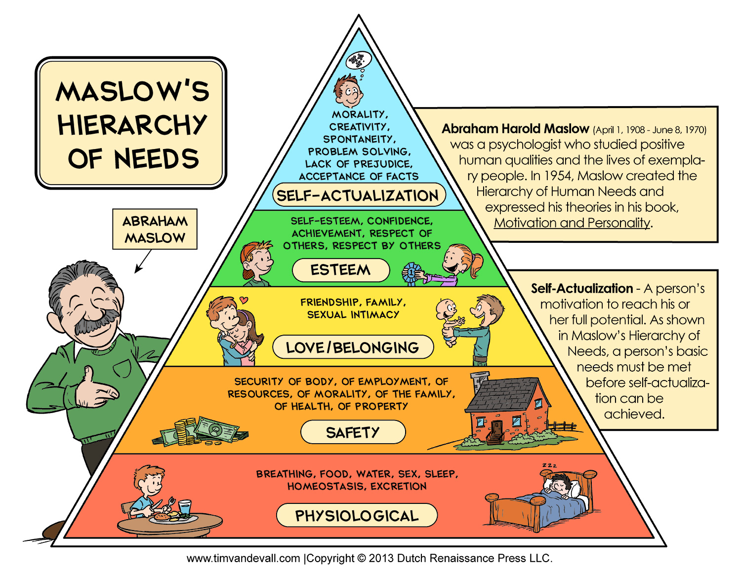
Maslow’s hierarchy of needs
Depression
Coping with disaster/crisis
Functional mental disorders
Organize mental disorders
Relationship bonds
Interpersonal conflict
Good communication
Forms of abuse
Empathy
Mental/emotional health
Hormones
Personal identity
Defense mechanisms
Modeling
Emotions
Hostility
Essays! Choose 2. Ten points each
-Advice for a friend going through a stressful situation
-Fight or flight response
-Warning signs for suicide; what to do?
-Four traits of a healthy relationship

Psychosomatic response
Protective factors
Stressors
Stress-management skills
Stress, occasional and chronic
Anxiety
Resiliency
Perception
Different types of emotional disorders
Coping
Cluster suicides
Different types of therapies
Personality
Self-talk
Different types of medical professionals who treat emotional/behavioral problems

10 x-choice, 3 sets of (10 point) matching, 15 true/false, 4 essay choices = 75 points

Date: _____________________

