We the People: Unit 3 Test
Lessons 15 - 20
10 Matching from Vocab (study online!)
8 – 10 Matching of Supreme Court cases (study online!)
10 True/False (from book content)
10 – 15 Multiple choice (from book content)
1 essay (15 points): Discuss the idea of “separate but equal”, as viewed by the government/courts, from the Declaration of Independence to today.

Factual content to know (for true/false and x-choice questions):
How constitution is amended
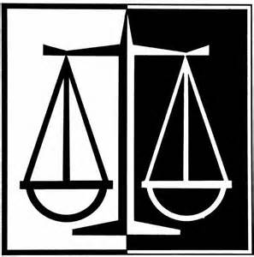
Type of amendments that have been adopted
Importance of Marbury vs. Madison
Federalists vs. Democratic (Jeffersonian) Republicans
Party system politics: pros and cons
Why did political parties develop?
Alien and Sedition Acts
Hamilton vs. Jefferson: constitutional interpretation
Van Buren’s opinions on party system
Purpose of a platform
Missouri Compromise details
Implications of Dred Scott decision
Confederate constitution
Lincoln’s wartime presidential powers
Civil War amendments: #s, what they did, why necessary
Procedural due process
Adversarial vs. inquisitorial systems
Substantive due process
Equal protection clause and impact on Constitution
Jim Crow laws
Plessy v. Ferguson: long term implications
NAACP
How “equal protection clause” been changed/interpreted in recent years
Expansion of voting rights: white men, women, racial minorities, youth
Roadblocks to voting, esp. for blacks

