We the People: Unit 5 Test
Lessons 27 – 32

10 – 15 Matching from Vocab (study online!)
10 – 15 Matching from court cases (online, in class, in lessons)
10 “Matching”: identify the # of the amendment and the right (Bill of Rights only)
10 – 15 True/False (from book content)
10 – 15 Multiple choice (from book content)
Essay: How are the Bill of Rights important to you today? Must explain (and identify by #) at least 2. 10 points.

Factual content to know (for true/false and x-choice questions):

Origins of U.S. Bill of Rights
Who may hold rights?
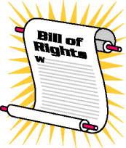
Bill of Rights #1-8, 9, 10
Categories of rights
Personal rights in the Articles
Establishment clause
Separation of church and state
Broad vs. narrow, literal interpretation
Free exercise clause
John Peter Zenger case
Why freedom of expression important?
Limitations on rights
Times of war and the Bill of Rights
NAACP
Types of warrants
General warrants
Probable cause-importance
Exclusionary rule
Self-incrimination
Burden of proof
Miranda Rights
Rights before, during, after a trial
Bail

